Name of Student: Aniruddha Pratap Singh | PRN:25070122247
Semester: III | Year : AY 2026-27
Subject: Programming with Java
ASSIGNMENT No : 4
TITLE : Wrapper Classes in Java
Problem Statement
Develop a Java application demonstrating the use of wrapper classes for conversion between primitive data types and objects, and performing basic operations on wrapped values.
Learning Objectives
To perform conversion between primitive data types and wrapper objects using Java wrapper classes.

Programme:
import java.util.Scanner;

public class PayrollApp {
public static void main(String
args[]) {
Scanner sc = new Scanner(System.in);

System.out.print("Enter Emp ID: ");
String s1 = sc.next();

System.out.print("Enter Basic: ");
String s2 = sc.next();

System.out.print("Enter Bonus: ");
String s3 = sc.next();

Integer empid = Integer.valueOf(s1);
Double basic = Double.valueOf(s2);
Double bonus = Double.valueOf(s3);

if (empid <= 0) {
System.out.println("Invalid Emp ID!");
} else if (basic <= 0) {
System.out.println("Invalid Basic Salary!");
} else if (bonus < 0) {
System.out.println("Invalid Bonus!");
} else {
double net = basic + bonus;
System.out.println("Emp ID: " + empid);
System.out.println("Net Salary: " + net);
}

sc.close();
}
}

Output:
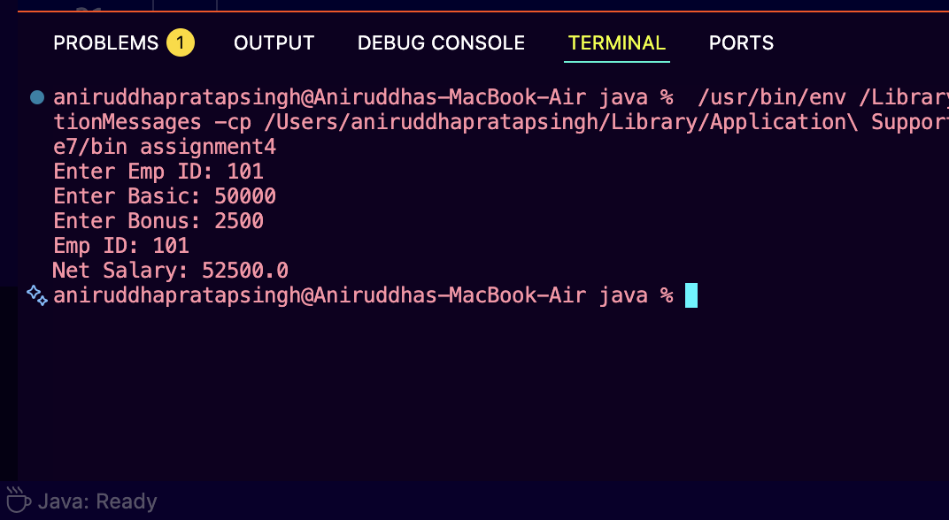
// Assignment 4 - Exercise 1: Wrapper class conversion for student marks
import java.util.*;
public class WrapperStudent
{
public static void main(String args[])
{
Scanner sc = new Scanner(System.in);
System.out.print("Enter Subject 1 Marks: ");
String m1 = sc.next();
System.out.print("Enter Subject 2 Marks: ");
String m2 = sc.next();
Name of Student : Raghav Mahesh Sarda PRN: 25070122235
Subject: Programming with Java Semester: III
ASSIGNMENT No : 4 Year: AY 2026-27
TITLE : Wrapper Classes in Java

JAVA Name: Aniruddha pratap Singh PRN: 25070122247
Integer marks1 = Integer.valueOf(m1); // Converting String to
Integer object
Integer marks2 = Integer.valueOf(m2); // Converting String to
Integer object

int total = marks1 + marks2; // Auto-unboxing and arithmetic
addition
System.out.println("Total Marks: " + total); // Displaying total
sc.close(); // Closing scanner
}
}
import java.util.Scanner;
Q2.
public class WrapperStudent {
public static void main(String args[]) {
Scanner sc = new Scanner(System.in);

System.out.print("Enter Subject 1 Marks: ");
String m1 = sc.next();

System.out.print("Enter Subject 2 Marks: ");
String m2 = sc.next();

// Name of Student : Aniruddha Pratap Singh PRN: 25070122247
// Subject: Programming with Java Semester: III
// ASSIGNMENT No : 4 Year: AY 2026-27
// TITLE : Wrapper Classes in Java

// JAVA Name: Aniruddha pratap Singh PRN: 25070122247

// Converting String to Integer object
Integer marks1 = Integer.valueOf(m1);

// Converting String to Integer object
Integer marks2 = Integer.valueOf(m2);

// Auto-unboxing and arithmetic addition
int total = marks1 + marks2;

// Displaying total
System.out.println("Total Marks: " + total);

// Closing scanner
sc.close();
}
}
Output:
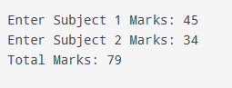
Conclusion:
This program covers the basics of getting user input with the Scanner class and parsing that text data into usable numbers. Adding the if-else conditions was a good way to see how to protect the code from bad inputs, ensuring the salary calculation only happens if the ID and pay amounts are actually valid.

